Platform as a Service (PaaS)
# Source: AI Source: Provided by: [Data Path: Persons Table -> ID Column: 1, Name_En Column: Motasem Essam] -> From: [ChatGPT] on [1/26/2026]
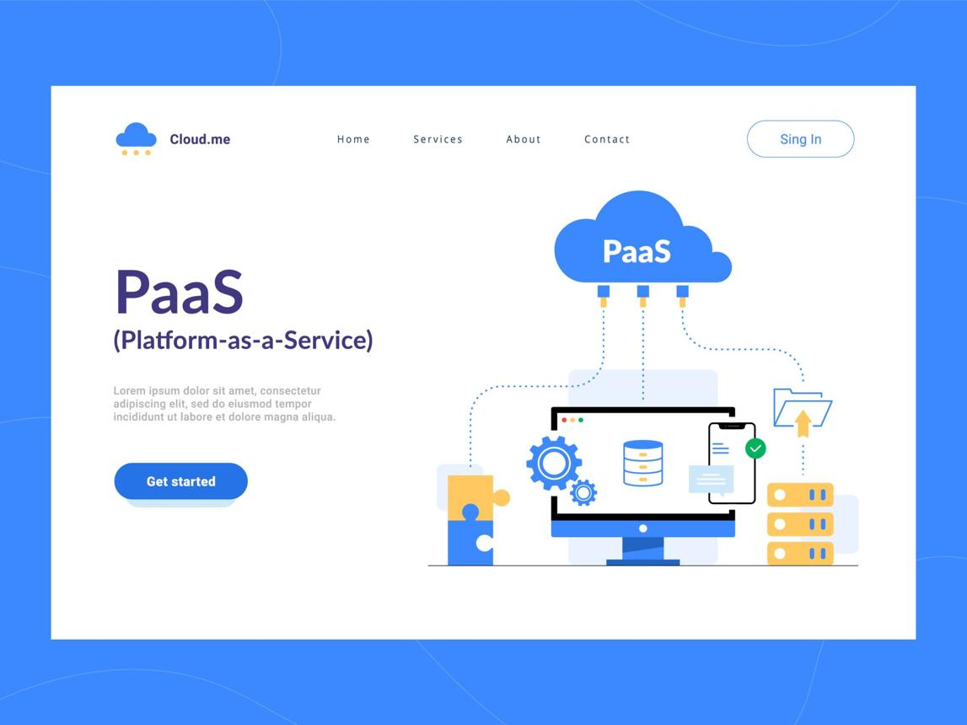
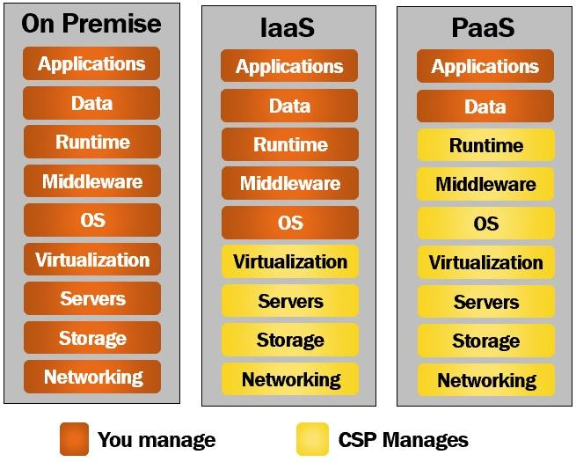
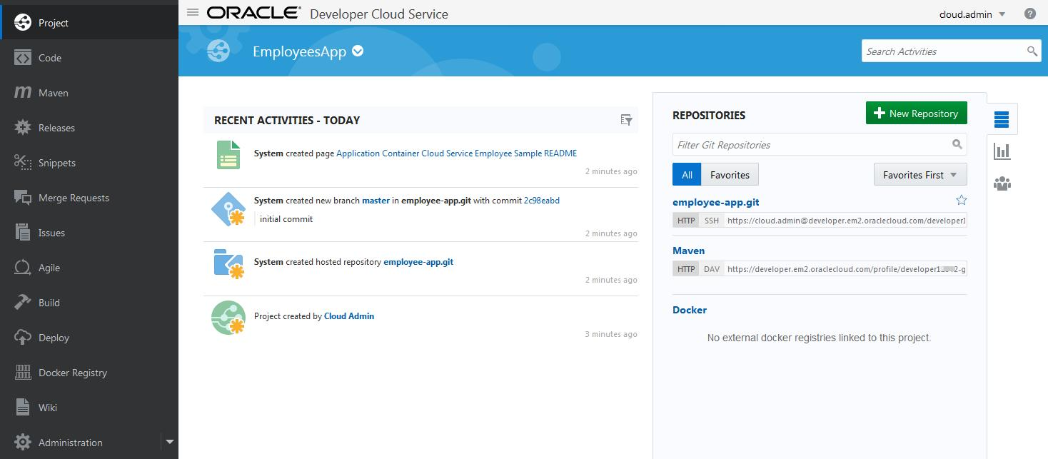
Platform as a Service (PaaS) is a cloud computing model that provides a ready-to-use platform for developing, running, and managing applications without the complexity of maintaining the underlying infrastructure (servers, storage, networking).

🧠 Simple Explanation
# Source: AI Source: Provided by: [Data Path: Persons Table -> ID Column: 1, Name_En Column: Motasem Essam] -> From: [ChatGPT] on [1/26/2026]
Think of PaaS like a pre-built workspace for developers:
- You focus on coding and deploying apps
- The provider handles hardware, OS, and runtime environments

⚙️ What You Get in PaaS
# Source: AI Source: Provided by: [Data Path: Persons Table -> ID Column: 1, Name_En Column: Motasem Essam] -> From: [ChatGPT] on [1/26/2026]
- 🖥️ Application hosting environment
- 🧩 Development tools (IDE, APIs, SDKs)
- 🌐 Networking and middleware
- 💾 Databases and storage solutions
👉 You manage:
- Your application code
- App configuration
- User permissions

🏢 Popular PaaS Providers
# Source: AI Source: Provided by: [Data Path: Persons Table -> ID Column: 1, Name_En Column: Motasem Essam] -> From: [ChatGPT] on [1/26/2026]
- Heroku
- Google App Engine
- Microsoft Azure App Services

🔑 Key Features
# Source: AI Source: Provided by: [Data Path: Persons Table -> ID Column: 1, Name_En Column: Motasem Essam] -> From: [ChatGPT] on [1/26/2026]
- No need to manage servers or OS
- Pre-configured development environment
- Scalable automatically with app demand
- Supports multiple programming languages

📦 Example
# Source: AI Source: Provided by: [Data Path: Persons Table -> ID Column: 1, Name_En Column: Motasem Essam] -> From: [ChatGPT] on [1/26/2026]
A team wants to launch a web application:
- Use Heroku to deploy the app
- Focus only on coding features
- The platform handles scaling, security, and deployment

✅ Advantages
# Source: AI Source: Provided by: [Data Path: Persons Table -> ID Column: 1, Name_En Column: Motasem Essam] -> From: [ChatGPT] on [1/26/2026]
- Faster development and deployment
- Reduces infrastructure management
- Easy collaboration for teams
- Automatic updates and maintenance

⚠️ Disadvantages
# Source: AI Source: Provided by: [Data Path: Persons Table -> ID Column: 1, Name_En Column: Motasem Essam] -> From: [ChatGPT] on [1/26/2026]
- Less control over underlying infrastructure
- Dependent on provider’s tools and environment
- Possible vendor lock-in

📌 Summary
# Source: AI Source: Provided by: [Data Path: Persons Table -> ID Column: 1, Name_En Column: Motasem Essam] -> From: [ChatGPT] on [1/26/2026]
PaaS provides a complete cloud-based platform for developers to build, deploy, and manage applications without worrying about underlying hardware or software infrastructure.

